Aim
To descibe the handling (storage and waste) of dry ice in the Laboratory clinic.

User group
All employees and students at the Laboratory clinic who use dry ice.

Changes to this version:
Do not write in the log. Changes are noted in «Merknad til denne versjonen» in the Document window
Version | Changes to this version
1.00 | Ny. Oversatt D60461 til engelsk.

Contents
1. Introduction 1
2. What is dry ice? 1
3. Transport of dry ice by lift 2
4. Storage of dry ice 2
5. How to dispose of dry ice? 2
5.1 Emptying of dry ice outside («Fjellvegg») 2
References 3

Introduction
Dry ice is either ordered or delivered with samples and reagents to keep them cold. Dry ice is used in the delivery of samples to other laboratories and hospitals.
On arrival, dry ice may be stored and reused by other users, but usually sublimes, where solid dry ice becomes CO₂ gas. Dry ice should not be left in a confined space as CO₂ is given off under thawing, which requires oxygen.
We have collaborated with Helen Stavang, occupational hygenist at the occupational health service, raised the issue at Laboratory meetings and talked to Einar Syvertsen at Ice Tech Norge AS (producer and distributor of dry ice).

What is dry ice?
- Dry ice is carbon dioxide (CO₂) in its solid state
- Dry ice has a temperature of -78,5 ºC
- Dry ice becomes CO₂ gas (sublimation)
- 1 kg dry ice is the equivalent of 530 litres CO₂
- A 1 kg block measures 125 x 27 x 210 mm (0.71 dm³ or 0.00071 m³)
- Relative density: approx. 1.4 kg/dm³
Due to its particular properties dry ice requires special precautions
Dry ice is extremely cold (−78.5 °C) and must not come in direct contact with skin. Use insulated protective gloves when handling to prevent frostbite.
Dry ice is constantly subliming to CO₂ gas, and therefore should not be kept in a closed container, as pressure will increase causing the container to explode. Carbon dioxide is heavier than air and the gas will settle on the floor before it mixes with the air in the room.
Under normal pressure dry ice does form liquid CO₂, but sublimes, that is to say it becomes carbon dioxide gas, hence the name dry ice.
At atmospheric pressure, CO₂ will sublime at temperatures higher than -78.5 ºC, that is to say that dry ice goes from solid to gas. CO₂ in its self is not poisonous, but has a suffocating effect as oxygen in air is depleted.
Long term exposure to 4 - 5 % CO₂ can lead to unconsciousness. Exposure to 8 % CO₂ after 30-60 min leads to coma and even death.

Transport of dry ice by lift
If a large volume of dry ice is to be transported by lift the container lid must be a good fit. In the event of the lift stopping for a long time this could be a problem. One can also transport dry ice unaccompanied with a warning label.

Storage of dry ice
Dry ice should be stored at -80 ºC, in its own freezer without reagents and samples, as CO₂ can affect the contents.
According to Syvertsen, storing large volumes of dry ice at -20 ºC is dangerous. It is okay to store small amounts for a short time in a -20 ºC freezer reserved for dry ice.

How to dispose of dry ice?
Through experience and working with this problem there are three proposed alternatives.
- Dry ice is spread outside the building («Fjellvegg», as illustrated at the end of the document)
- Dry ice may be placed on the terrace on the 5th or 7th floor in a labelled polystyrene box (to be collected when empty)
- Small* amounts of dry ice may be placed in a fumehood to sublime

Larger orders (eg., from Biorad) may contain 10 liters of dry ice (the equivalent of 14 kg) or more. The dry ice must be spread over the gravel or the box with dry ice placed on one of the terraces.
Dry ice must not be rinsed down the sink or in the toilet as it damages the drain pipes.

Emptying of dry ice outside («Fjellvegg»)
It has been agreed with Maintenance and A&E that dry ice may be disposed of by spreading it out on the gravel between the asphalt and rock at the side of the Lab building, opposite A&E (see photos below).
Ensure that there is no polystyrene littering the area, and that the dry ice is not in the way of vehicles and pedestrians in the area.
*Small amounts of dry ice refers to a cubic decimeter, the equivalent of 1 litre. 3 - 4 dm³ (3 - 4 litres) is the equivalent of approximately 4-6 kg dry ice, which is considered a small amount.
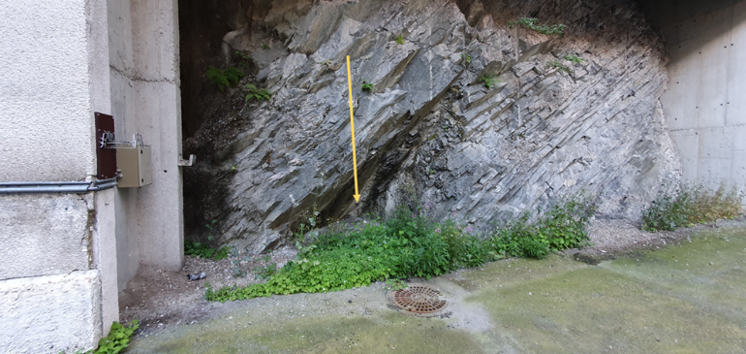
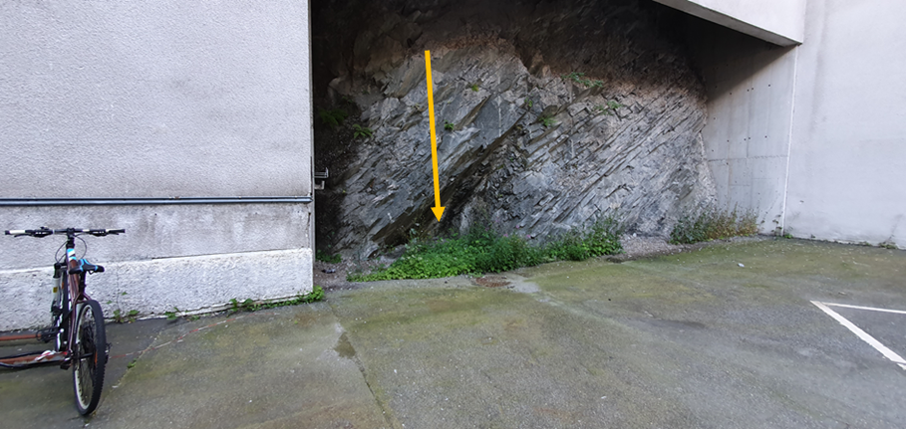

References
Internal references
External references

